EXERCISE 7
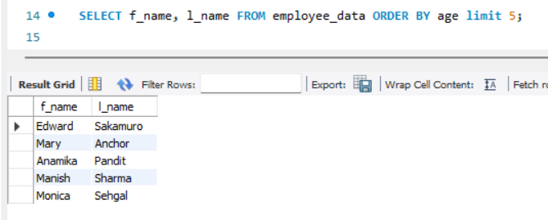
- List the names of 5 youngest employees in the company.

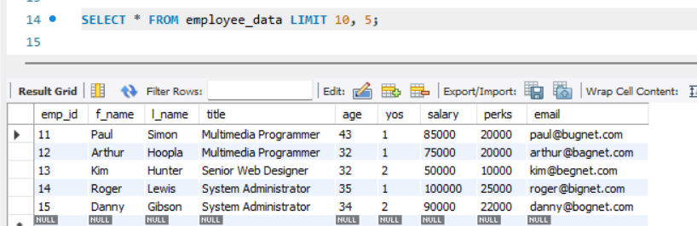
- Extract the next 5 entries starting with the 10 row.

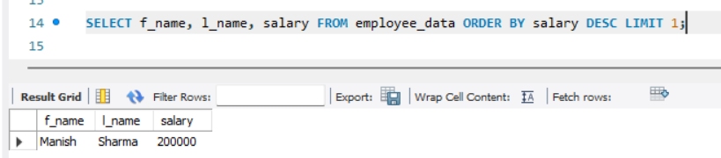
- Display the names and salary of the employee who draws the largest salary.

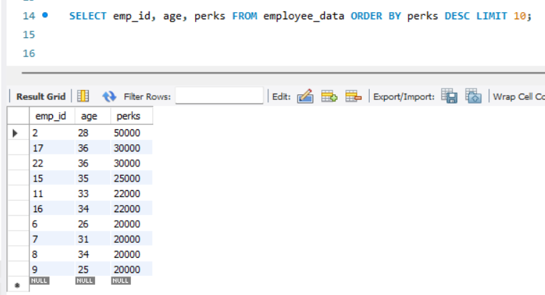
- What does the following statement display?

